EXPERIMENT-1

Connect the computers in Local Area Network

Aim: To connect the computers in Local Area Network.

Apparatus:
Personal computer.

Procedure: On the host computer

On the host computer, follow these steps to share the Internet connection:

- Log on to the host computer as Administrator or as Owner.
- Click Start, and then click Control Panel.

Click Network and Internet Connections.
- Click Network Connections.
- Right-click the connection that you use to connect to the Internet. For example, if you connect to the Internet by using a modem, right-click the connection that you want under Dial-up/other network available.
- Click Properties.
- Click the Advanced tab.
- Under Internet Connection Sharing, select the Allow other network users to connect through this computer's Internet connection check box.
- If you are sharing a dial-up Internet connection, select the Establish a dial-up connection whenever a computer on my network attempts to access the Internet check box if you want to permit your computer to automatically connect to the Internet.
- Click OK. You receive the following message:

When Internet Connection Sharing is enabled, your LAN adapter will be set to use IP address 192.168.0.1. Your computer may lose connectivity with other computers on your network. If these other computers have static IP addresses, it is a good idea to set them to obtain their IP addresses automatically. Are you sure you want to enable Internet Connection Sharing?

- Click Yes.
The connection to the Internet is shared to other computers on the local area network (LAN).

The network adapter that is connected to the LAN is configured with a static IP address of 192.168.0.1 and a subnet mask of 255.255.255.0.

On the client computer

To connect to the Internet by using the shared connection, you must confirm the LAN adapter IP configuration, and then configure the client computer. To confirm the LAN adapter IP configuration, follow these steps:

- Log on to the client computer as Administrator or as Owner.
- Click Start, and then click Control Panel.

Click Network and Internet Connections.
- Click Network Connections.
- Right-click Local Area Connection and then click Properties.
- Click the General tab, click Internet Protocol (TCP/IP) in the connection uses the following items list, and then click Properties.
- In the Internet Protocol (TCP/IP) Properties dialog box, click Obtain an IP address automatically (if it is not already selected), and then click OK.

Note: You can also assign a unique static IP address in the range of 192.168.0.2 to 192.168.0.254. For example, you can assign the following static IP address, subnet mask, and default gateway:

8. IP Address 192.168.31.202
9. Subnet mask 255.255.255.0
- Default gateway 192.168.31.1
- In the Local Area Connection Properties dialog box, click OK.
- Quit Control Panel.

Result:
Hence, the computers are connected in Local Area Network.

EXPERIMENT-2
Configure Host IP, Subnet Mask and Default Gateway in a system in LAN (TCP/IP configuration)

Aim: To configure Host IP, Subnet Mask and Default Gateway in a System in LAN
(TCP/IP Configuration).

Apparatus:
1.Personal computer.

Principle: Following is required to be study under this practical.

- Classification of IP address

Class A 1.0.0.1 to 126.255.255.254 Supports 16 million hosts on each of 127 networks.
Class B 128.1.0.1 to 191.255.255.254 Supports 65,000 hosts on each of 16,000 networks.
Class C 192.0.1.1 to 223.255.254.254 Supports 254 hosts on each of 2 million networks.
Class D 224.0.0.0 to 239.255.255.255 Reserved for multicast groups.
Class E 240.0.0.0 to 254.255.255.254 Reserved.

- Sub netting
Why we Develop sub netting and How to calculate subnet mask and how to identify subnet address?

- Super netting
Why we develop super netting and How to calculate supernet mask and how to identify supernet address?

Procedure:

Steps to configure IP address, Subnet mask and Default Gateway:
- Click on the Start button and select Control Panel then Network and Internet Connections.
- Click Network and Internet Connections.
- Right click on the Local Area Connection icon and select Properties.
- Select Internet Protocol (TCP/IP).
- Click on the Properties button.
- Uncheck that Obtain an IP address automatically and Obtain DNS server address automatically and put IP, Subnet mask & Default Gateways.
- Click on the Advanced button and select the DNS tab in the Advanced TCP/IP Settings window.
- Ensure that Register this connection's addresses in DNS is not selected.
- Click OK, OK, then Close to close all boxes.

Result:
Configuration of Host IP Address in a system in LAN (TCP/IP Configuration) and Configuration to establish Subnet Mask and Default Gateway have been done successfully.

EXPERIMENT-3
Establish peer to peer network connection using two systems (direct connection or via switch/router) in a LAN for sharing the drives and folders

Aim: To establish Peer to Peer network connection using two systems in a LAN and Switch and Router in a LAN for sharing the drives and folders.

Apparatus:
1.Personal computer.

Principle:

All PCs must have networking hardware already installed. Examine the back of the PC for an RJ45 port (it looks like a port for a typical phone but is wider with eight contacts).
If you have more than two PCs, you will need at least one multi-port sharing device like a hub, switch, or router with enough ports to support all your PCs.
If you are only networking two PCs, all you need is one crossover cable. You do not need a hub, switch, or router.
Multi-port sharing devices that work for creating small networks:
Hubs are usually the least expensive of the devices. Hubs simply repeat the data flow out to the other lines. These works good in small networks.

Switches are like hubs but filter IP addresses to increase data flow in larger networks.
Routers become necessary when networking over 254 computers. A router can also be used to share one IP address with several other PCs
The network link between PCs can only be as fast as the slowest device in the link. Try to use all networking devices with the same speed rating for optimal performance (this include cables).
Try to keep hubs, switches, and routers accessible.

Some hubs, switches, and routers, require the last port be used only when the cascade port is not already in use. Do not connect a network cable for a PC into the cascade port.

Procedure:
Stepping into Peer-to-Peer:
Click Start, Control Panel, Network Connections.
- Select Set up a home or small office network link under Network Tasks On the left-side.

- The Welcome to the Network Setup Wizard screen on the Network Setup Wizard appears. Click Next.

- The Before you continue screen appears, listing the steps that will be completed. Click the checklist for creating a network link.

- Close the Steps for creating a home or small office network screen.
- Click Next on the Before you continue screen.
- Connect the network interfaces click Next.
- The Select a connection method screen appears. Here you will select from three connection options Make your selection and click Next.

- On the Select your Internet connection screen, select the network connection that relates to the Internet under Connections and click Next. You must make a selection or the Next button will remain grayed out.

- The next screen, your computer has multiple connections, is very important for both Internet connectivity and firewall issues. It's here you begin to assist the wizard by defining the "inside" network adapter (local area network) and the "wild-side" network adapter (Internet connection). Make the appropriate selection and click Next. In my case, I selected Let me choose the connections to my network.

- Because of the selection I made in, the Select the connections to bridge appears. Make the connection selection and click Next.
- Complete the Computer description and Computer name fields on the Give this computer.

- Complete the Workgroup name field on the Name your network screen and click next.
- Review your settings on the Ready to apply your network settings Screen and click next.

- Click Finish after the configuration process is completed.

Result:

Peer to Peer network connection using two systems using Switch and Router in a LAN have been done successfully.

EXPERIMENT- 4

Study of basic network commands and network configuration commands

Aim: To Study of basic network commands and network configuration commands.

Apparatus:
Hardware: Personal computer.
Software: Command Prompt.
Packet Tracer.

Procedure: To do this EXPERIMENT- follows these steps:

In this EXPERIMENT- students have to understand basic networking commands e.g. ping, tracert etc.

All commands related to Network configuration which includes how to switch to privilege mode and normal mode and how to configure router interface and how to save this configuration to flash memory or permanent memory.

This command includes

  - Configuring the Router commands.
  - General Commands to configure network.
  - Privileged Mode commands of a router.
  - Router Processes & Statistics.
  - IP Commands.
  - Other IP Commands e.g. show IP route etc.

ping:
ping(8) sends an ICMP ECHO_REQUEST packet to the specified host. If the host responds, you get an ICMP packet back. Sound strange? Well, you can “ping” an IP address to see if a machine is alive. If there is no response, you know something is wrong.
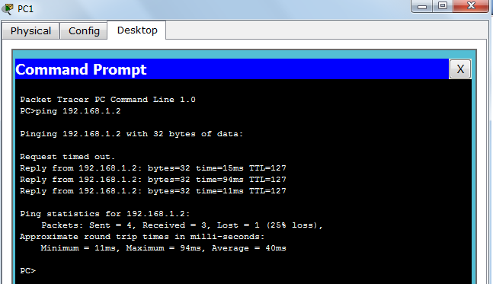

Traceroute:

Tracert is a command which can show you the path a packet of information takes from your computer to one you specify. It will list all the routers it passes through until it reaches its destination, or fails to and is discarded. In addition to this, it will tell you how long each 'hop' from router to router takes.

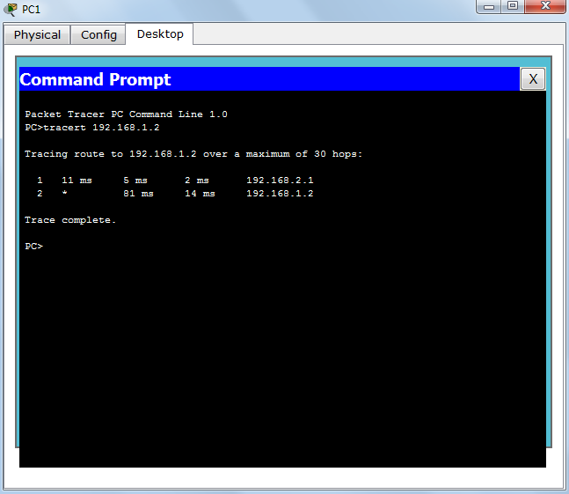

nslookup:

Displays information from Domain Name System (DNS) name servers.
NOTE :If you write the command as above it shows as default your pc's server name firstly.

pathping:
A better version of tracert that gives you statics about packet lost and latency.

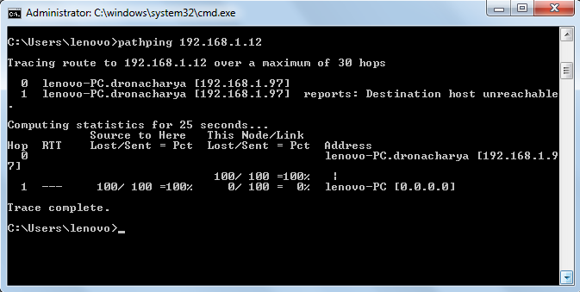

Getting Help

In any command mode, you can get a list of available commands by entering a question mark (?). Router>?
To obtain a list of commands that begin with a particular character sequence, type in those characters followed immediately by the question mark (?).

Router#co?

configure connect copy
To list keywords or arguments, enter a question mark in place of a keyword or argument. Include a space before the question mark.

Router#configure ?

memory Configure from NV memory network Configure from a TFTP network host terminal Configure from the terminal
You can also abbreviate commands and keywords by entering just enough characters to make the command unique from other commands. For example, you can abbreviate the show command to sh.

Configuration Files

Any time you make changes to the router configuration, you must save the changes to memory because if you do not they will be lost if there is a system reload or power outage. There are two types of configuration files: the running (current operating) configuration and the startup configuration.
Use the following privileged mode commands to work with configuration files.
    - configure terminal – modify the running configuration manually from the terminal.

    - show running-config – display the running configuration.

    - show startup-config – display the startup configuration.

    - copy running-config startup-config – copy the running configuration to the startup
configuration.

    - copy startup-config running-config – copy the startup configuration to the running
configuration.

    - erase startup-config – erase the startup-configuration in NVRAM.

    - copy tftp running-config – load a configuration file stored on a Trivial File Transfer Protocol (TFTP) server into the running configuration.

    - copy running-config tftp – store the running configuration on a TFTP server.

IP Address Configuration

Take the following steps to configure the IP address of an interface.

Step 1: Enter privileged EXEC mode:

Router>enable password

Step 2: Enter the configure terminal command to enter global configuration mode. Router#config terminal
Step 3: Enter the interface type slot/port (for Cisco 7000 series) or interface type port (for Cisco 2500 series) to enter the interface configuration mode.

Example:
Router (config)#interface ethernet 0/1
Step 4: Enter the IP address and subnet mask of the interface using the ip address ipaddress subnetmask command.

Example,
Router (config-if)#ip address 192.168.10.1 255.255.255.0

Step 5: Exit the configuration mode by pressing Ctrl-Z Router(config-if)#[Ctrl-Z]

Result:
Hence, basic network commands and network configuration commands are studied.

EXPERIMENT- 5

Configure different Network topologies

Aim: To configure different Network topologies.

Apparatus:
Hardware: Personal computer.
Software: Command Prompt.
Packet Tracer.

Procedure:
1. Develop a Topology shown in figure given below.
2.Configure all PC’s.
3.To implement this practical following network topology is required to be configured
4.After configuring the given network, a packet should be ping from any one machine to another.

Bus:

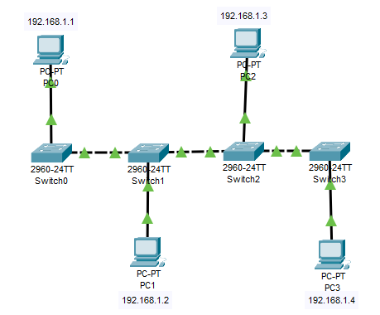

Ping PC-1 to PC-3:-

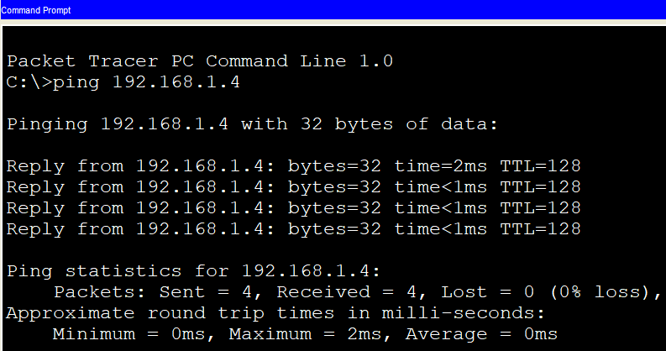

Ring:

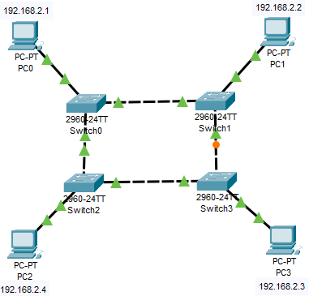

Ping PC-3 to PC-0:-

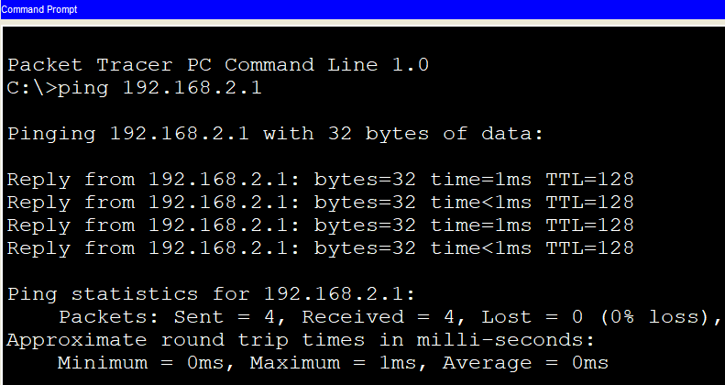

Star:

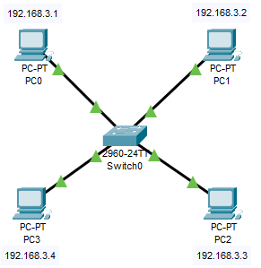
Ping PC-3 to PC-1

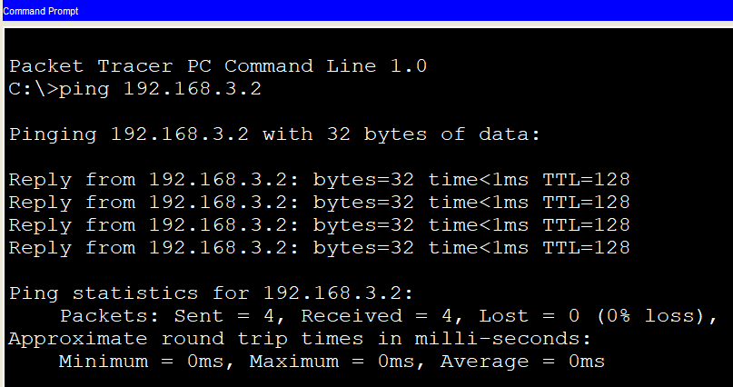

Hybrid:

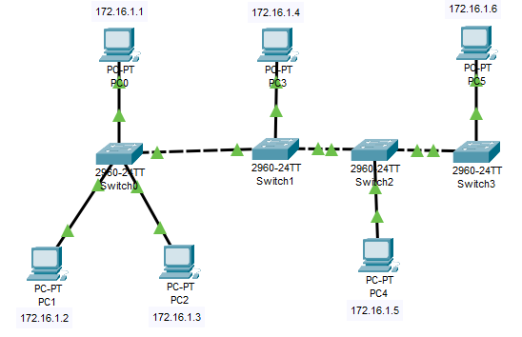

Ping PC-5 to PC-1:-
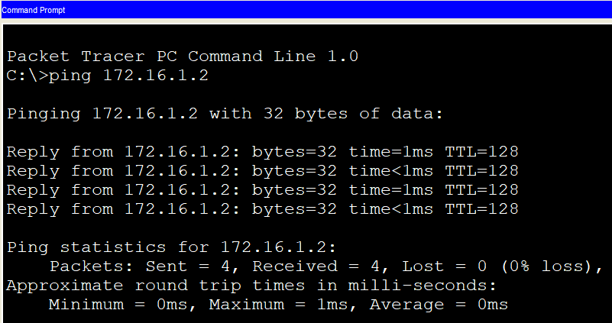

Ping PC-4 to PC-0:-
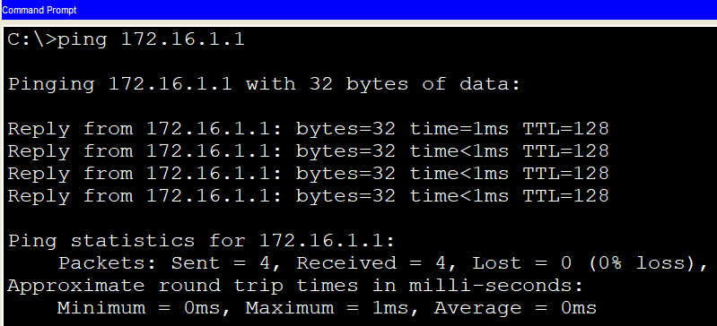

Result:
Configuration of different network topologies have been done successfully.

EXPERIMENT- 6

Simulation of Ethernet LAN protocol connected via hubs, switches

Aim: To simulate Ethernet LAN protocol connected via hubs, switches.

Apparatus:
Hardware: Personal computer.
Software: Command Prompt.
Packet Tracer.

Procedure:
- Develop a Topology shown in figures given below.
- Configure hub and switch.
3. Configure all PC’s.
4. To implement this practical following network topology is required to be configured.
5. After configuring the given network a packet should be ping from any one machine to another.

Ethernet LAN Protocol Connected Via Hub:

192.168.1.3 192.168.1.1
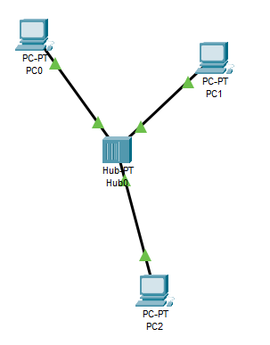
192.168.1.2

Packet from PC1 to PC2

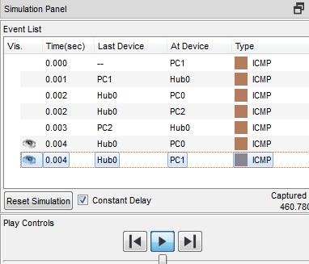

Ethernet LAN Protocol Connected Via Switch:

192.168.1.3 192.168.1.1

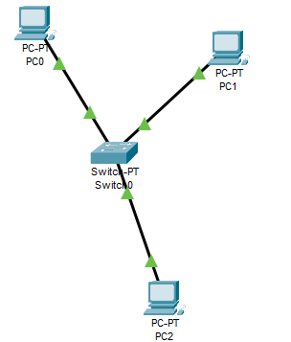
192.168.1.2

Packet from PC1 to PC2

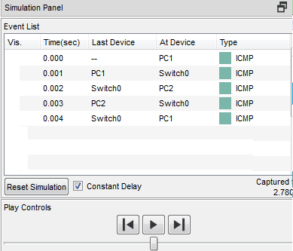

C:\>ping 192.168.1.2

Pinging 192.168.1.2 with 32 bytes of data:

Reply from 192.168.1.2: bytes=32 time=1ms TTL=128
Reply from 192.168.1.2: bytes=32 time<1ms TTL=128
Reply from 192.168.1.2: bytes=32 time=1ms TTL=128
Reply from 192.168.1.2: bytes=32 time=1ms TTL=128

Ping statistics for 192.168.1.2:
Packets: Sent = 4, Received = 4, Lost = 0 (0% loss),
Approximate round trip times in milli-seconds:
Minimum = 0ms, Maximum = 1ms, Average = 0ms

C:\>ping 192.168.1.1

Pinging 192.168.1.1 with 32 bytes of data:

Reply from 192.168.1.1: bytes=32 time=1ms TTL=128
Reply from 192.168.1.1: bytes=32 time=1ms TTL=128
Reply from 192.168.1.1: bytes=32 time<1ms TTL=128
Reply from 192.168.1.1: bytes=32 time=1ms TTL=128

Ping statistics for 192.168.1.1:
Packets: Sent = 4, Received = 4, Lost = 0 (0% loss),
Approximate round trip times in milli-seconds:
Minimum = 0ms, Maximum = 1ms, Average = 0ms

C:\>ping 192.168.1.3

Pinging 192.168.1.3 with 32 bytes of data:

Reply from 192.168.1.3: bytes=32 time=14ms TTL=128
Reply from 192.168.1.3: bytes=32 time=7ms TTL=128
Reply from 192.168.1.3: bytes=32 time=7ms TTL=128
Reply from 192.168.1.3: bytes=32 time=1ms TTL=128

Ping statistics for 192.168.1.3:
Packets: Sent = 4, Received = 4, Lost = 0 (0% loss),
Approximate round trip times in milli-seconds:
Minimum = 1ms, Maximum = 14ms, Average = 7ms

Result:
Ethernet LAN protocol connected via hubs, switches have been simulated using packet tracer.

EXPERIMENT- 7

Simulation of Wireless LAN

Aim: To simulate Wireless LAN.

Apparatus:
Hardware: Personal computer.
Software: Command Prompt.
Packet Tracer.

Procedure:
- Develop a Topology shown in figure given below.
- Configure router, PC and switch (Wired devices).
3. Configure all devices (PC, Laptop, Tablet, Smartphone and Printer) wireless.
4. To implement this practical following network, topology is required to be configured.
5. After configuring the given network a packet should be ping from any one machine to another.

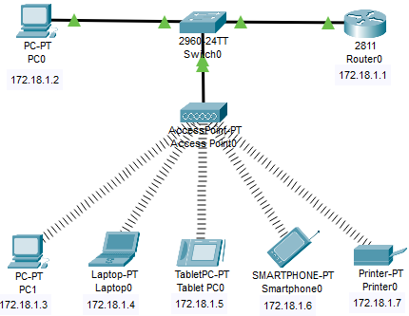

Router0 Configuration Command:
Continue with configuration dialog? [yes/no]: no
Press RETURN to get started!
router>
router>Enable
router# configure terminal
Enter configuration commands, one per line. End with CNTL/Z.

Router(config)#hostname router0 router0(config)#interface fastethernet 0/0
router0(config-if)# ip address 172.18.1.1 255.255.0.0 router0(config-if)#no shutdown
router0(config-if)#end
router0 #

Packet from PC0 to Tablet

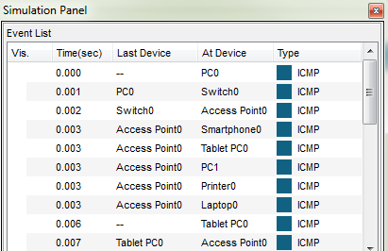

Packet Tracer PC Command Line 1.0
From PC-0
C:\>ping 172.18.1.3

Pinging 172.18.1.3 with 32 bytes of data:

Reply from 172.18.1.3: bytes=32 time=1ms TTL=255
Reply from 172.18.1.3: bytes=32 time<1ms TTL=255
Reply from 172.18.1.3: bytes=32 time<1ms TTL=255
Reply from 172.18.1.3: bytes=32 time<1ms TTL=255

Ping statistics for 172.18.1.3:
Packets: Sent = 4, Received = 4, Lost = 0 (0% loss),
Approximate round trip times in milli-seconds:
Minimum = 0ms, Maximum = 1ms, Average = 0ms

C:\>ping 172.18.1.4

Pinging 172.18.1.4 with 32 bytes of data:

Reply from 172.18.1.4: bytes=32 time=37ms TTL=128
Reply from 172.18.1.4: bytes=32 time=9ms TTL=128
Reply from 172.18.1.4: bytes=32 time=25ms TTL=128
Reply from 172.18.1.4: bytes=32 time<1ms TTL=128

Ping statistics for 172.18.1.4:
Packets: Sent = 4, Received = 4, Lost = 0 (0% loss),
Approximate round trip times in milli-seconds:
Minimum = 0ms, Maximum = 37ms, Average = 17ms

C:\>ping 172.18.1.5

Pinging 172.18.1.5 with 32 bytes of data:

Reply from 172.18.1.5: bytes=32 time=60ms TTL=128
Reply from 172.18.1.5: bytes=32 time=40ms TTL=128
Reply from 172.18.1.5: bytes=32 time=17ms TTL=128
Reply from 172.18.1.5: bytes=32 time=32ms TTL=128

Ping statistics for 172.18.1.5:
Packets: Sent = 4, Received = 4, Lost = 0 (0% loss),
Approximate round trip times in milli-seconds:
Minimum = 17ms, Maximum = 60ms, Average = 37ms

C:\>ping 172.18.1.6

Pinging 172.18.1.6 with 32 bytes of data:

Reply from 172.18.1.6: bytes=32 time=37ms TTL=128
Reply from 172.18.1.6: bytes=32 time=7ms TTL=128
Reply from 172.18.1.6: bytes=32 time=36ms TTL=128
Reply from 172.18.1.6: bytes=32 time=4ms TTL=128

Ping statistics for 172.18.1.6:
Packets: Sent = 4, Received = 4, Lost = 0 (0% loss),
Approximate round trip times in milli-seconds:
Minimum = 4ms, Maximum = 37ms, Average = 21ms

C:\>ping 172.18.1.7

Pinging 172.18.1.7 with 32 bytes of data:

Reply from 172.18.1.7: bytes=32 time=31ms TTL=128
Reply from 172.18.1.7: bytes=32 time=4ms TTL=128
Reply from 172.18.1.7: bytes=32 time=18ms TTL=128
Reply from 172.18.1.7: bytes=32 time=35ms TTL=128

Ping statistics for 172.18.1.7:
Packets: Sent = 4, Received = 4, Lost = 0 (0% loss),
Approximate round trip times in milli-seconds:
Minimum = 4ms, Maximum = 35ms, Average = 22ms

Result:
Hence, wireless LAN have been simulated successfully using packet tracer.

EXPERIMENT- 8
Configure a Network using Distance Vector Routing algorithm

Aim: To configure a Network using Distance Vector Routing protocol.
- Routing Information Protocol (RIP).

Apparatus:
Hardware: Personal computer.
Software: Command Prompt.
Packet Tracer.

Procedure:
- Develop a Topology shown in figure given below.
- Configure all the work stations.
- Configure all Switches
- Configure all Routers
- To implement RIP protocols in Router, configure Network.

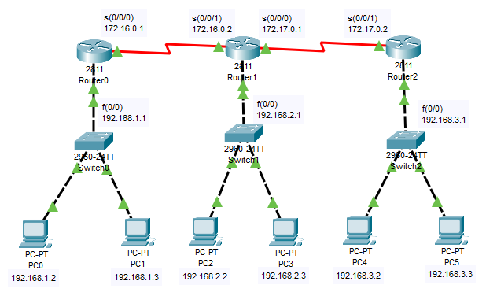

Router 0 configuration.....
Note: Initial Configuration means we are activating the LAN Port and WAN Ports (Router ports) by assigning the IP Addresses.

Router >
Router > enable
Router #
Router # configure terminal
Enter configuration commands, one per line. End with CNTL/Z
To change Router name type
Router (config) # hostname router 0
Router 0 (config) #interface fastethernet 0/0
Router 0 (config-if) # ip address 192.168.1.1 255.255.255.0
Router 0 (config-if) # no shutdown
Router 0 (config-if) # exit
Router 0 (config) # interface serial 0/0/0
Router 0 (config-if) # ip address 172.16.0.1 255.255.0.0
Router 0 (config-if) # no shutdown
Router 0 (config-if) # clock rate 64000
Router 0 (config-if) # encapsulation hdlc
Router 0 (config-if) # exit
Router 0 (config) # exit
Router 0 #

Router 1 Configuration:-
Router >
Router > enable
Router #
Router # configure terminal
Enter configuration commands, one per line. End with CNTL/Z
To change Router name type
Router (config) # hostname router 1
Router 1 (config) #interface fastethernet 0/0
Router 1 (config-if) # ip address 172.18.1.3 255.255.255.0
Router 1 (config-if) # no shutdown
Router 1 (config-if) # exit
Router 1 (config) # interface serial 0/0/1
Router 1 (config-if) # ip address 172.16.0.2 255.255.0.0
Router 1 (config-if) # no shutdown
Router 1 (config-if) # clock rate 64000
Router 1 (config-if) # encapsulation hdlc
Router 1 (config-if) # exit
Router 1 (config) # exit
Router 1 #
Router 1 (config) # interface serial 0/0/0
Router 1 (config-if) # ip address 172.17.0.1 255.255.0.0
Router 1 (config-if) # no shutdown
Router 1 (config-if) # clock rate 64000
Router 1 (config-if) # encapsulation hdlc
Router 1 (config-if) # exit
Router 1 (config) # exit
Router 1 #

Router 2 configuration:-

Router >
Router > enable
Router #
Router # configure terminal
Enter configuration commands, one per line. End with CNTL/Z
To change Router name type
Router (config) # hostname router 2
Router 2 (config) #interface fastethernet 0/0
Router 2 (config-if) # ip address 192.168.3.1 255.255.255.0
Router 2 (config-if) # no shutdown
Router 2 (config-if) # exit
Router 2 (config) # interface serial 0/0/1
Router 2 (config-if) # ip address 172.17.0.2 255.255.0.0
Router 2 (config-if) # no shutdown
Router 2 (config-if) # clock rate 64000
Router 2 (config-if) # encapsulation hdlc
Router 2 (config-if) # exit
Router 2 (config) # exit
Router 2 #
Verification:- show ip interface brief

Now configure RIP Protocol to all Routers
Note:- Any Routing Protocol works in Global Configuration Mode only
For Router 0 :-
Router 0 >
Router 0 > enable
Router 0 #
Router 0 # configure terminal
Enter configuration commands, one per line. End with CNTL/Z
Router 0 (config) # ip routing
Router 0 (config) # router rip
Router 0 (config-router) # network 192.168.1.0
Router 0 (config-router) # network 172.16.0.0
Router 0 (config-router) # exit
Router 0 (config) # exit
Router 0 #
For Router 1:-

Router 1 >
Router 1 > enable
Router 1 #
Router 1 # configure terminal
Enter configuration commands, one per line. End with CNTL/Z
Router 1 (config) # ip routing
Router 1 (config) # router rip
Router 1 (config-router) # network 192.168.2.0
Router 1 (config-router) # network 172.17.0.0
Router 1 (config-router) # network 172.16.0.0
Router 1 (config-router) # exit
Router 1 (config) # exit
Router 1 #

For Router 2 :-

Router 2 >
Router 2 > enable
Router 2 #
Router 2 # configure terminal
Enter configuration commands, one per line. End with CNTL/Z
Router 2 (config) # ip routing
Router 2 (config) # router rip
Router 2 (config-router) # network 192.168.3.0
Router 2 (config-router) # network 172.17.0.0
Router 2 (config-router) # exit
Router 2 (config) # exit
Router 2 #

Verification:- show ip route

Result:
Hence, A network using distance vector routing algorithm is configured.

EXPERIMENT- 9

Configure a Network using Link State Routing Algorithm

Aim: To configure Network using Link State Routing protocol.
- Open Shortest Path First (OSPF).

Apparatus:
Hardware: Personal computer.
Software: Command Prompt.
Packet Tracer.

Procedure:

- Develop a Topology shown in figure given below.
- Configure all the workstations.
- Configure all switches.
- Configure all Routers.
- Implement OSPF protocols in Router to configure Network.

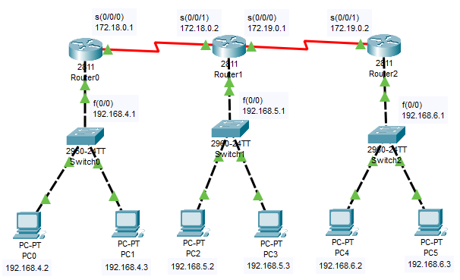

Router 0 configuration.....
Note: Initial Configuration means we are activating the LAN Port and WAN Ports (Router ports) by assigning the IP Addresses.

Router >
Router > enable
Router #
Router # configure terminal
Enter configuration commands, one per line. End with CNTL/Z
To change Router name type
Router (config) # hostname router 0
Router 0 (config) #interface fastethernet 0/0
Router 0 (config-if) # ip address 192.168.4.1 255.255.255.0
Router 0 (config-if) # no shutdown
Router 0 (config-if) # exit
Router 0 (config) # interface serial 0/0/0
Router 0 (config-if) # ip address 172.18.0.1 255.255.0.0
Router 0 (config-if) # no shutdown
Router 0 (config-if) # clock rate 64000
Router 0 (config-if) # encapsulation hdlc
Router 0 (config-if) # exit
Router 0 (config) # exit
Router 0 #

Router 1 Configuration:-
Router >
Router > enable
Router #
Router # configure terminal
Enter configuration commands, one per line. End with CNTL/Z
To change Router name type
Router (config) # hostname router 1
Router 1 (config) #interface fastethernet 0/0
Router 1 (config-if) # ip address 192.168.5.1 255.255.255.0
Router 1 (config-if) # no shutdown
Router 1 (config-if) # exit
Router 1 (config) # interface serial 0/0/1
Router 1 (config-if) # ip address 172.18.0.2 255.255.0.0
Router 1 (config-if) # no shutdown
Router 1 (config-if) # clock rate 64000
Router 1 (config-if) # encapsulation hdlc
Router 1 (config-if) # exit
Router 1 (config) # exit
Router 1 #
Router 1 (config) # interface serial 0/0/0
Router 1 (config-if) # ip address 172.19.0.1 255.255.0.0
Router 1 (config-if) # no shutdown
Router 1 (config-if) # clock rate 64000
Router 1 (config-if) # encapsulation hdlc
Router 1 (config-if) # exit
Router 1 (config) # exit
Router 1 #

Router 2 Configuration:-
Router >
Router > enable
Router #
Router # configure terminal
Enter configuration commands, one per line. End with CNTL/Z
To change Router name type
Router (config) # hostname router 2
Router 2 (config) #interface fastethernet 0/0
Router 2 (config-if) # ip address 192.168.6.1 255.255.255.0
Router 2 (config-if) # no shutdown
Router 2 (config-if) # exit
Router 2 (config) # interface serial 0/0/1
Router 2 (config-if) # ip address 172.19.0.2 255.255.0.0
Router 2 (config-if) # no shutdown
Router 2 (config-if) # clock rate 64000
Router 2 (config-if) # encapsulation hdlc
Router 2 (config-if) # exit
Router 2 (config) # exit
Router 2 #
Verification:- show ip interface brief

Now configure OSPF Protocol to all Routers

Note:- Any Routing Protocol works in Global Configuration Mode only

For Router 0 :-

Router 0 >
Router 0 > enable
Router 0 #
Router 0 # configure terminal
Enter configuration commands, one per line. End with CNTL/Z
Router 0 (config) # ip routing
Router 0 (config) # router ospf 1
Router 0 (config-router) # router-id 1.1.1.1
Router 0 (config-router) # network 192.168.4.0 0.0.0.255 area 1
Router 0 (config-router) # network 172.18.0.0 0.0.255.255 area 0
Router 0 (config-router) # exit
Router 0 (config) # exit
Router 0 #

For Router 1:-

Router 1 >
Router 1 > enable
Router 1 #
Router 1 # configure terminal
Enter configuration commands, one per line. End with CNTL/Z
Router 1 (config) # ip routing
Router 1 (config) # router ospf 2
Router 1 (config-router) # router-id 2.2.2.2
Router 1 (config-router) # network 192.168.5.0 0.0.0.255 area 0
Router 1 (config-router) # network 172.19.0.0 0.0.255.255 area 0
Router 1 (config-router) # network 172.18.0.0 0.0.255.255 area 0
Router 1 (config-router) # exit
Router 1 (config) # exit
Router 1 #

For Router 2 :-

Router 2 >
Router 2 > enable
Router 2 #
Router 2 # configure terminal
Enter configuration commands, one per line. End with CNTL/Z
Router 2 (config) # ip routing
Router 2 (config) # router ospf 3
Router 2 (config-router) # router-id 3.3.3.3
Router 2 (config-router) # network 192.168.6.0 0.0.0.255 area 2
Router 2 (config-router) # network 172.19.0.0 0.0.255.255 area 0
Router 2 (config-router) # exit
Router 2 (config) # exit
Router 2 #

Verification:- show ip route

Result:
Hence, A network using link state routing algorithm is configured.

EXPERIMENT-10
Standard access control list (ACL) configuration in packet tracer.

Aim: To configure Standard Access Control List by using any protocol like
RIP or OSPF.

Apparatus:
Hardware: Personal Computer.
Software: Command Prompt.
Packet Tracer.

Procedure:
- Develop a topology shown in figure given below.
- Configure all work Stations.
- Configure all Routers.
- Configure all Switches.
- Implement any protocol i.e., RIP or OSPF in all Routers to Configure the Network.

Router 0 Initial Configuration:-

Note: Initial Configuration means we are activating the LAN Port and WAN Ports (Router ports) by assigning the IP Addresses and Similarly for Router 1 & Router 2.

Router >
Router > enable
Router #
Router # configure terminal
Enter configuration commands, one per line. End with CNTL/Z
To change Router name type
Router (config) # hostname router 0
Router 0 (config) #interface fastethernet 0/0
Router 0 (config-if) # ip address 192.168.1.1 255.255.255.0
Router 0 (config-if) # no shutdown
Router 0 (config-if) # exit
Router 0 (config) # interface serial 0/0/0
Router 0 (config-if) # ip address 172.16.0.1 255.255.0.0
Router 0 (config-if) # no shutdown
Router 0 (config-if) # clock rate 64000
Router 0 (config-if) # encapsulation hdlc
Router 0 (config-if) # exit
Router 0 (config) # exit
Router 0 #
After Completion of all Routers initial configuration do any Routing Protocol also means RIP or OSPF for all routers what we have done in previous practices

Configuration of Standard ACL:
Creation of Standard Access List:
Syntax: Router (config) # access-list <acl no.><permit/deny><source address><source wild card mask>
Implementation of Standard Access List:
Syntax: Router (config) # interface<interface type><interface no>
Router (config) # ip access-group<number><out/in>
Configuration: Router 1 (config) # access-list 10 deny 192.168.1.2 0.0.0.0
Router 1 (config)# access-list 10 permit any
Implementation- Router 1 (config)# interface fastethernet 0/0
Router 1 (config-if) # ip access-group 10 out
Router (config-if) #exit.

Verification: Show access-list

Result:
Standard Access control list using packet tracer is configured and here PC2 to PC0 two way communication is blocked through Router1.

EXPERIMENT-11
Extended access control list (ACL) configuration in packet tracer.

Aim: To configure Extended Access Control List by using any protocol like
RIP or OSPF.

Apparatus:
Hardware: Personal Computer.
Software: Command Prompt, Packet Tracer.

Procedure:
- Develop a topology shown in figure given below
- Configure all work Stations
- Configure all Routers
- Configure all Switches
- Implement any protocol i.e., RIP or OSPF in all Routers to Configure the Network.

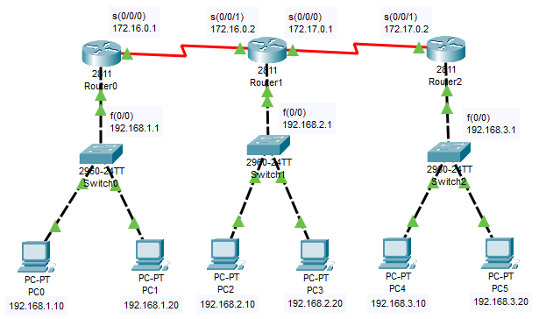

Router 0 Initial Configuration:

Note: Initial Configuration means we are activating the LAN Port and WAN Ports (Router ports) by assigning the IP Addresses and Similarly for Router 1 & Router 2

Router >
Router > enable
Router #
Router # configure terminal
Enter configuration commands, one per line. End with CNTL/Z
To change Router name type
Router (config) # hostname router 0
Router 0 (config) #interface fastethernet 0/0
Router 0 (config-if) # ip address 192.168.1.1 255.255.255.0
Router 0 (config-if) # no shutdown
Router 0 (config-if) # exit
Router 0 (config) # interface serial 0/0/0
Router 0 (config-if) # ip address 172.16.0.1 255.255.0.0
Router 0 (config-if) # no shutdown
Router 0 (config-if) # clock rate 64000
Router 0 (config-if) # encapsulation hdlc
Router 0 (config-if) # exit
Router 0 (config) # exit
Router 0 #

After Completion of all Routers initial configuration do any Routing Protocol also means RIP or OSPF for all routers what we have done in previous practices

Configuration of Extended ACL:
Creation of Extended Access List:
Syntax:-
Router (config) # access-list <acl no.><permit/deny><Protocol><source address> <source wild card mask><destination address><destination wild card mask><operator><service>
Implementation of Extended Access List:
Syntax: Router (config) # interface<interface type><interface no.>
Router (config) # ip access-group<number><out/in>
Configuration: Router (config) # access-list 101 deny icmp 172.18.1.30 0.0.0.0 192.168.1.10 0.0.0.0 echo
Router (config) # access-list 101 permit icmp any any
Implementation: Router (config) # interface fastethernet 0/0
Router (config) # ip access-group 101 in
Router (config) # exit

Verification: Show access-list

Result:
Hence, Extended access control list is configured in packet tracer and here PC2 to PC0 one way communication is blocked through Router1.

EXPERIMENT-12
Building a LAN with Hubs and Switches

Aim: To build a LAN with Hubs and Switches.

Apparatus:
Hardware: Personal computer.
Software: Command Prompt.
Packet Tracer.

Procedure:
- Develop a Topology shown in figures given below.
- Configure hub and switch.
3. Configure all PC’s.
4. To implement this practical following network topology is required to be configured.
5. After configuring the given network a packet should be ping from any one machine to another.

LAN Connected Via Hub:

LAN Connected Via Switch:

C:\>ping 192.168.1.2

Pinging 192.168.1.2 with 32 bytes of data:

Reply from 192.168.1.2: bytes=32 time=1ms TTL=128
Reply from 192.168.1.2: bytes=32 time<1ms TTL=128
Reply from 192.168.1.2: bytes=32 time=1ms TTL=128
Reply from 192.168.1.2: bytes=32 time=1ms TTL=128

Ping statistics for 192.168.1.2:
Packets: Sent = 4, Received = 4, Lost = 0 (0% loss),
Approximate round trip times in milli-seconds:
Minimum = 0ms, Maximum = 1ms, Average = 0ms

C:\>ping 192.168.1.1

Pinging 192.168.1.1 with 32 bytes of data:

Reply from 192.168.1.1: bytes=32 time=1ms TTL=128
Reply from 192.168.1.1: bytes=32 time=1ms TTL=128
Reply from 192.168.1.1: bytes=32 time<1ms TTL=128
Reply from 192.168.1.1: bytes=32 time=1ms TTL=128

Ping statistics for 192.168.1.1:
Packets: Sent = 4, Received = 4, Lost = 0 (0% loss),
Approximate round trip times in milli-seconds:
Minimum = 0ms, Maximum = 1ms, Average = 0ms

C:\>ping 192.168.1.3

Pinging 192.168.1.3 with 32 bytes of data:

Reply from 192.168.1.3: bytes=32 time=14ms TTL=128
Reply from 192.168.1.3: bytes=32 time=7ms TTL=128
Reply from 192.168.1.3: bytes=32 time=7ms TTL=128
Reply from 192.168.1.3: bytes=32 time=1ms TTL=128

Ping statistics for 192.168.1.3:
Packets: Sent = 4, Received = 4, Lost = 0 (0% loss),
Approximate round trip times in milli-seconds:
Minimum = 1ms, Maximum = 14ms, Average = 7ms

Result:
Hence, LAN connected via hubs, switches have been built.

